TTOASM
Module, Algorithm and Data Structure Design

Author: Louise Pathe
Document Revision: 1.2

Introduction:

The TrueType Open Assembler (TTOAsm) is a utility to allow the input of TrueType Open table data in text format. TTOAsm assembles that data into a binary TrueType Open table file which can then be added to a TrueType file using another utility AddTable.

The TrueType Open Assembler is to be designed with portability, extensibility, and time to completion as the top three priorities. Size and speed of the program are not of as great a concern, as this utility will be used rarely. First, modules will be described, then, the data structures to communicate between modules, and any special algorithms that are needed to perform the work of the TrueType Open Assembler.

Modules:

There are nine modules to TTOAsm.
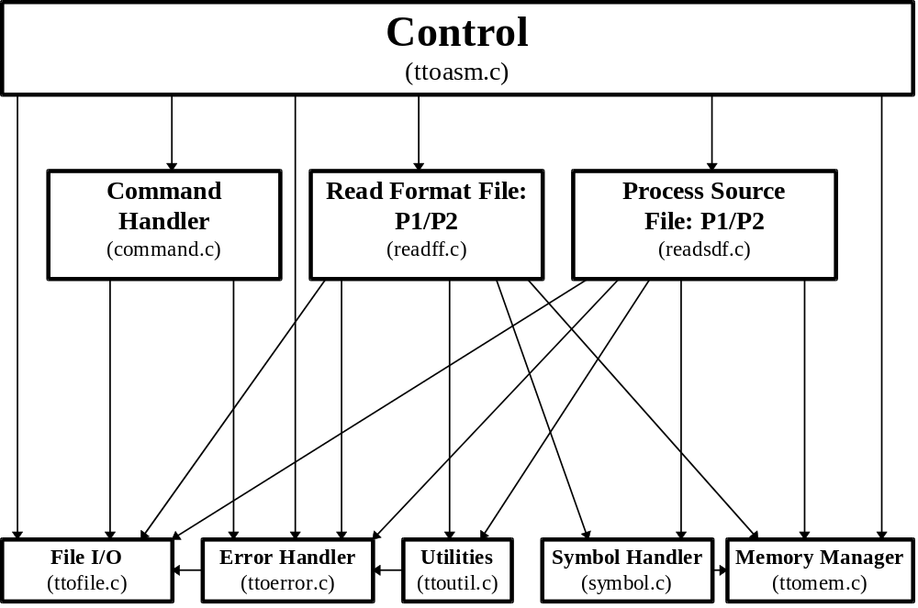

1. Control
This module handles program control and communication among the modules. This is where all file opening and closing occurs. When errors occur, program control is returned to this module so that cleanup can be performed and the program may exit.

2. Command Handler
The first module to be invoked by Control is the Command Handler. This module will accept input from a command file to specify what type of operation to perform on what file. The commands in the command file are:

<-SSrcDataFile> <-FFormaDefFile>[-BBinaryFile] [-LListFile] [-EErrorFile]

Where:

-SSrcDataFile is the name of the file that contains the data to be assembled into a binary TTO Table. This is a text file.

-FFormatDefFile is the name of the file that contains the Format Description Definition for the TTO Tables. This is a text file.

-BBinaryFile is the name of the output file to create. If this is not specified, no file will be created, only error checking will be performed.

-LListFile is the name of the Text list file to be created. If this is not specified, no file will be created.

-EErrorFile is the name of the output file where errors should be sent. If this is not specified errors are sent to Standard Error.

3. Symbol Module
This module is the interface between a Symbol Table and modules needing to create and manipulate it. The Read Format File Module will scan the Format file for structure names and constants. When it encounters a symbol, it will call the Symbol Module with an AddSymbol function. The Symbol Module will then add the symbol to the symbol table. Access to values stored with symbols is through GetSymbol. Additionally a ModifySymbol function is available to update symbol values.

4. Read Format File Module
This module is responsible for reading the Format File and creating in memory the Format Data Structures that the Process Source Data File Module will access. It will also build, with the aid of the Symbol Table Module, a Format File Symbol Table. In order to allow flexibility in the ordering of format definitions, this module will perform two passes through the file.

5. Process Source Data File Module
Pass 1 of this module scans the data file for symbols, builds a Data File Symbol Table and sets the values of those symbols. It uses the data structures created by the Read Format File Module in order to correctly parse the Data file. Once this pass is completed, all data values will be entered in an output buffer. Offset values will be written in pass 2.

Pass 2 will read the input file. When it encounters an Offset Label, it will look it up in the Data File Symbol table and write it out to the data buffer. Consistency checking for the CoverageCount, ClassCount and CheckRangeRecord functions will be performed here. Once the data has been accumulated and checked, it will be written to the output file.

6. File I/O
This module allows access to files for Data Input and Output files, as well as Error Handling. This module will be platform dependent.

7. Error Handler
This module allows reporting of errors. The module where the error occurred will call the Error Handler with and error string, then return an error code to the Control module. That will perform some housekeeping and then it will exit. If it is a warning only, the module where the error occurred will call a separate warning function with a string and will not return to the Control module.

8. Utilities
This module provides basic utilities for Read Format File and Process Source Data File modules.

7. Memory Manager
This module is a simple memory manager for the allocation and freeing of memory. It allocates memory in large blocks using malloc, and then parcels out that memory to the ttoasm functions that request it. At the end, control can call one function to free all the memory used by ttoasm.

Data Structures and Algorithms:

Most data structures that are private to a module will not be described here. Those used to communicate between modules are described below:

1. Control Module - ttoasm.c

2. Command Module - command.c
A data structure containing strings to be filled in will be created and shared with the Control Module. It will look like:

#define MAXFILENAMESIZE 256

typedef struct command *PCOMMAND;

struct command {
char szSrcDataFile[MAXFILENAMESIZE];
char szFormatDefFile[MAXFILENAMESIZE];
char szBinaryFile[MAXFILENAMESIZE];
char szListFile[MAXFILENAMESIZE];
char szErrorFile[MAXFILENAMESIZE];
};

3. Symbol Module
This module will communicate with the Read Format File and the Process Input Data File Modules via an opaque data structure. The client will not have knowledge of the structure. It will create, destroy and manipulate the structure via access functions.

struct symbol table;
typedef struct symbol *PSYMBOL;

4. Read Format File Module.
This module will create its own Symbol table. There are four different types of symbols to keep track of for the Format File.
1. Structure Names ; Names of structures - will be matched with data in Input Data File.
2. Data Type Labels ; such as uint16, fixed32
3. Function Lables ; such as BitCount0F
4. Constants

Two passes will be made through the file. The first pass will gather all the Structure names and enter them in the Format File Symbol table. It will also create an array of StructureDef structures (described below) with empty StructureElement pointers. The Second pass will then read the elements within the structures and create element records to attach to the StructureDefs. Each Entry in the Structure Definition table will point to a linked list of elements. Each uses the following data structures which is stored in a header file which is shared between readff.c and readsdf.c:

typedef struct calc_record *PCALC_LIST;

struct calc_record {
int32 lValue; /* numeric value instead of symbol. */
uint16 uMinMax; /* index for global MinMax defines (such as MMMinGIndex), 0 means none*/
uint16 uSymbElementType; /* 0 = none, 1 = $T, 2 = $R, 3 = $P */
uint16 iElementIndex; /* index to element in calculation - 1 based */
uint16 uOperation; /* operation to be performed on accumulated value */
uint16 uFunction; /* function to be performed on stuff in the function list. */
PCALC_LIST pFunctionList; /* calc list of stuff in function */
PCALC_LIST pNext; /* next record to include in calc. If NULL, end of calc */
};

typedef struct parameter_record *PPARAM_LIST;

struct parameter_record {
uint16 iElementIndex; /* which element or passed in parameter - 1 based */
uint16 uSymbElementType; /* - see calc_record above. */
PPARAM_LIST pNext;
};

typedef struct structure_element *PELEMENT_LIST;
typedef struct structure_element ELEMENT_LIST;

struct structure_element {
uint16 uType; /* 16 bits, see Element types above */
int16 iStructureIndex; /* used for Structure Type for Table Offset, Record or class member */
PCALC_LIST pMinCalc; /* calc record representing minimum value for this element */
PCALC_LIST pMaxCalc; /* if pMaxCalc is NULL, pMinCalc is identity */
PCALC_LIST pCountCalc; /* used to Calculate array Count */
PPARAM_LIST pParamList; /* list of parameters used for TableOffset types */
PELEMENT_LIST pNext; /* when NULL, this is the last element */
};

typedef struct structure_def * PSTRUCTURE_DEF;
typedef struct structure_def STRUCTURE_DEF;

struct structure_def {
PELEMENT_LIST pFirst;
uint16 cParameters; /* number of parameters this structure will reference */
};

typedef struct structure_list * PSTRUCTURE_LIST;

struct structure_list {
uint16 cStructures; /* number of structures in pStructureDef array */
PSTRUCTURE_DEF pStructureDef; /* array of structure_def structures */
void * pSymbolTable; /* Format File Symbol Table - void because ttoasm.c needn't know about it */
};

/* Symbol stuff for Format File*/
typedef struct ffsymbol_data *PFFSYMBOL_DATA;
typedef struct ffsymbol_data FFSYMBOL_DATA;

struct ffsymbol_data {
uint16 uSymbolType; /* TABLE, CLASS, RECORD, HEAD */
int16 iStructureIndex; /* index into structure_list.pStructureDef array of this structure */
};

5. Process Source Data File Module

The Process Source Data File Module will read text from the Source Data text file. Using the Structure Definition Table array and the Format File Symbol Table the file will be read and parsed. A second symbol table, the Data File Symbol table will be created and filled with values as they are read from the file. These symbols may be either Offset Labels or Constants.

This module will build, in memory, a buffer to hold the data read from file. It will then write it out to the output file.

In addition, a structure stack will be created. The stack points to the structures needed for the TTO Table being read. It represents the current state of the data file parsing. The lowest entry in the structure represents the structure of the TTO table (HEAD structure). Subsequent levels represent tables and array records belonging to the table.

Here is an outline of the algorithm for input proccessing and data management.

Pass 1
0. Set CurrentLocation value to 0
1. Read word of text from Source Data file
2. Determine its Type:
a. Constant Definition (“Foo=19”)
b. Constant Reference (“Foo” when non-offset expected, and not found in Format File Symbol table)
c. Structure Type Definition (“GPOSHeader” if expected and found in Format File Symbol table)
d. Offset Label Definition (“TheGPOSHeader” when following a Structure Type Definition)
e. Offset Label Reference (“TheGPOSHeader” when expecting an Offset value)
f. Data value (“12” when expecting a value)
g. Comment (“;This is a comment”)

3. If:
a. Constant Definition: Enter name, type, and value into Data File Symbol table
b. Constant Reference: Lookup value in Data File Symbol table (Constants must be defined before being referenced.) Proceed as for Data value below.

c. Structure Type Definition:
1) Lookup Structure Type in Format File Symbol Table. Check if type TABLE or HEAD.
2) If there, get a copy of that structure record. This corresponds to a TTO Table. TTO Records are not explicitly referenced in the Data File.
3) Put a pointer to that Structure Record on the top of the structure stack (which will be empty at this point). This is the current structure (CurrStruc) and will drive the interpretation of all data to be read until the structure has been closed and popped off the stack.
4) If this is the first structure ever on the stack, make sure it is a HEAD structure.
5) Set the BaseOffset value to the current offset. This will be used to calculate relative offsets for all offset values in this TTO Table.
6) Otherwise, report error

d. Offset Label Definition (follows Structure Type Definition):
1) Get StructureIndex for Structure Type Definition.
2) Lookup Label in Data File Symbol Table.
3) Should already be in table, as reference must occur before definition. Match structure type through Structure Indices
4) If not already in Data File Symbol table, report error.
5) Set Offset value in Data File Symbol Table (based on Current location and BaseOffset value)
6) Use Symbol Handler to get Parameters if needed.

e. Offset Label Reference:
1) Make sure that is what is expected by the Structure Record (element Type Offset)
2) Get StructureIndex for Structure Type of Offset Element
3) Lookup Label in Data File Symbol Table.
4) Symbol may already be there as more than one reference is legal for a single table.
5) If already there check offset type and structure index and check Parameter list values.
6) If not already in Data File Symbol table, create a new entry, set offset type and structure index, and create and fill in a Parameter List structure and pass to Symbol Handler for safe keeping
7) Increment CurrentLocation value by sizeof offset

f. Data Value:
1) Validate Size and Range based on Structure Record element and or Parameter List
2) Write value to buffer at CurrentLocation.
3) Increment CurrentLocation value (by sizeof element)
4) Move to next element in element list.
if the next element is:
1. NULL: this is last element, remove top structure record from structure stack.
2. Array: Make calculations for count using values in buffer.
3. Record:
Get the StructureIndex from the element, get a copy of the structure, and put a pointer to it on the structure stack.

g. Comment: Ignore but continue reading characters until end of line.

4. Repeat 1-3 until EOF.

5. Make Sure EOF corresponds with empty Structure Stack.

6. Once Data file has been read, all Offset values should be filled in Data File Symbol Table.

Pass 2
7. Read datafile again writing Offset values to buffer from Data File Symbol table.

8. Perform Limit checking for ClassCount, CoverageCount and CheckRangeRecord functions that require other table data before checking can occur.

9. Write data buffer to file..

6. File I/O - Console I/O
No Shared Data Structures or interesting algorithms

7. Error Handler
No Shared Data Structures or interesting algorithms

8. Utilities
No Shared Data Structures or interesting algorithms
7. Memory Manager
No Shared Data Structures or interesting algorithms

